Duplicating Events from Previous Year - 12/28/22
6 months ago Updated
When events are duplicated from the prior program year, it is important for Event Admins to check the Registration Type setup before they open the event for new registrations. The Registration Type details copy literally from the event that was duplicated, so you need to update that information to reflect the new event/dates.
Make sure that following pieces of information are appropriately updated for each registration type:
- Update the program year for the Registration Type.
- Update the Registration Dates for each Registration Type.
- Update the Deposit Full Amount Due Date if the Registration Type requires a deposit.
- Update the Registration Type Settings - if you have restricted the registration type by Program Youth Division, or Program Age or Program Grade, - you will need to set these options again. The system is copying forward the Youth Restriction Type, but does not copy forward the divisions, ages or grades at this time. ** This item is in Productboard - please use the following link to add your vote/insight.

DUPLICATING Events:
- Click on the Events tab
- Change program year to prior year
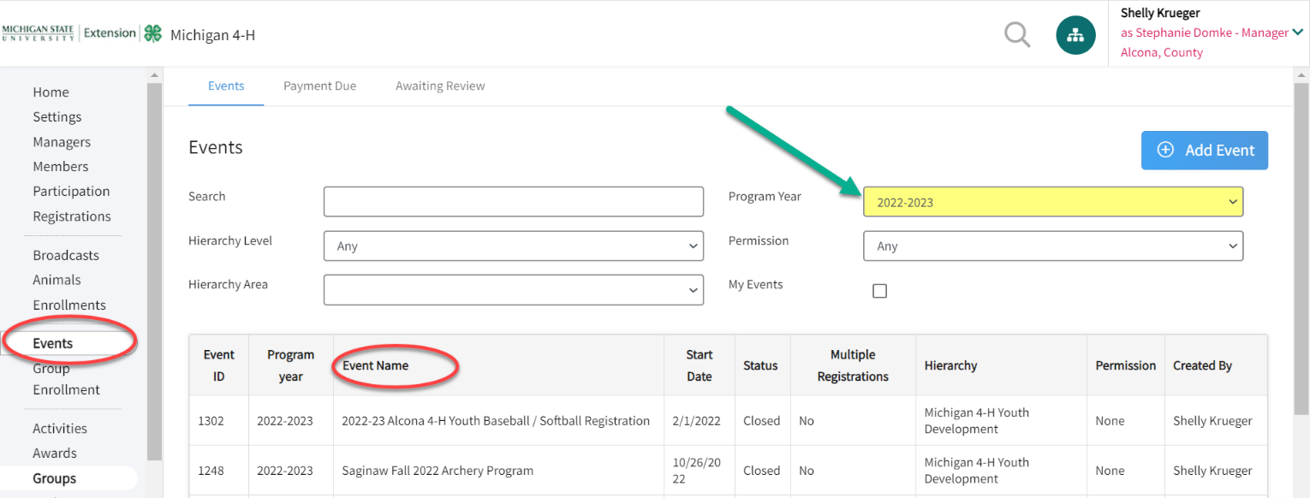
- Select the event you wish to duplicate

- Click on the Duplicate tab
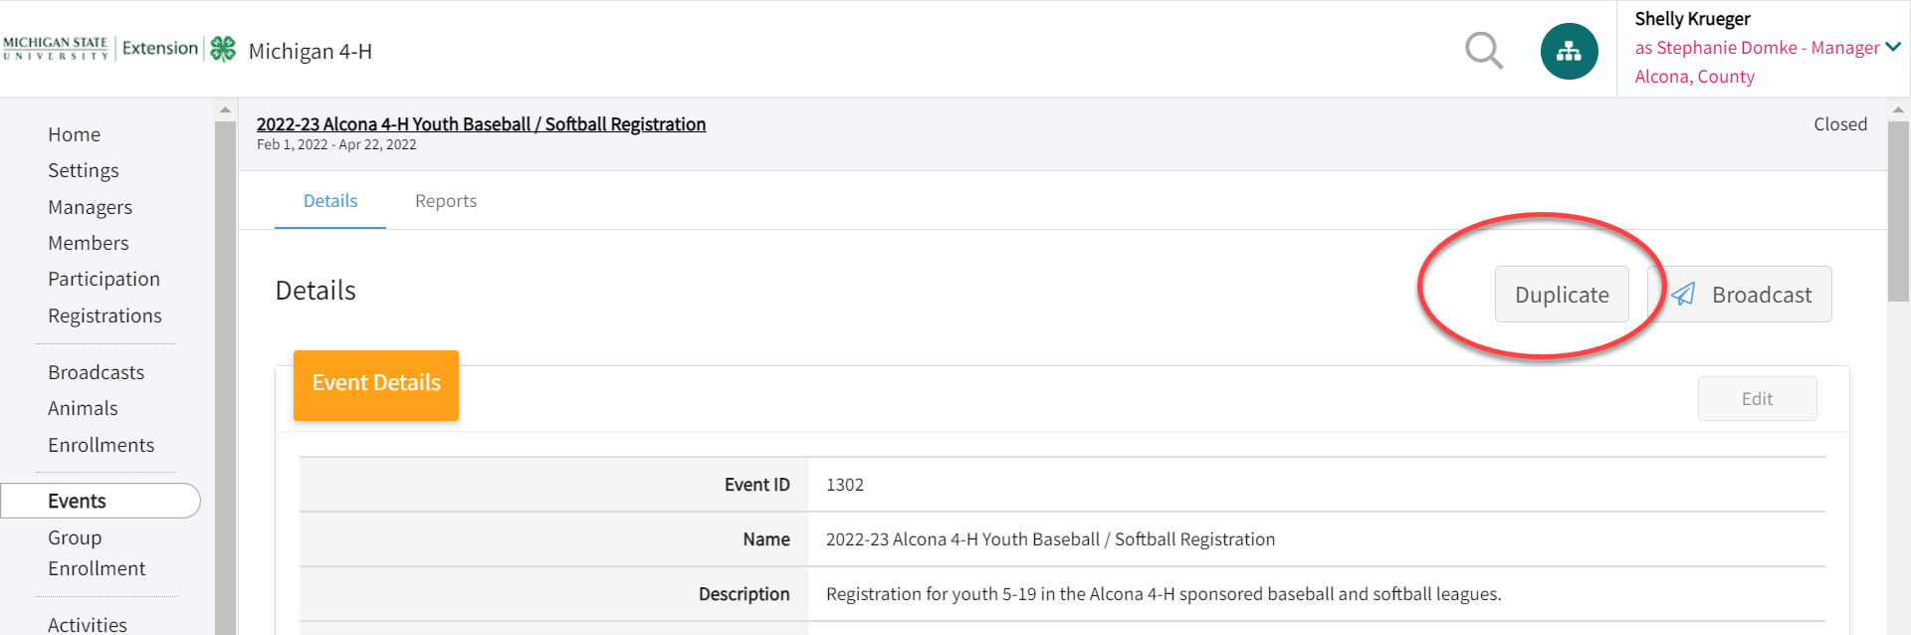
- Click on the Program Year to change to the current program year
- Change Start Dates and End Dates
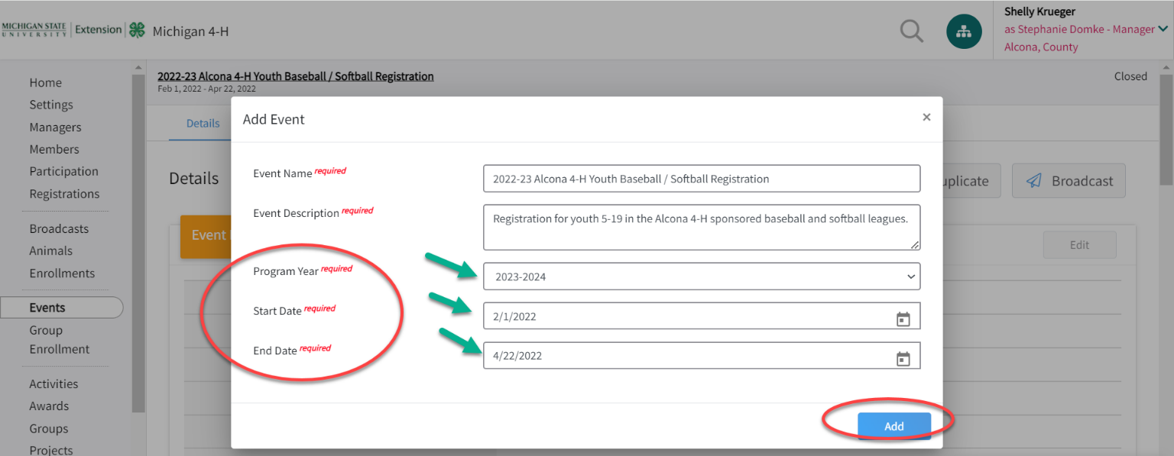
- Click Add
- Go back to the Events tab
- Locate the event just duplicated
- Change the event status to TESTING

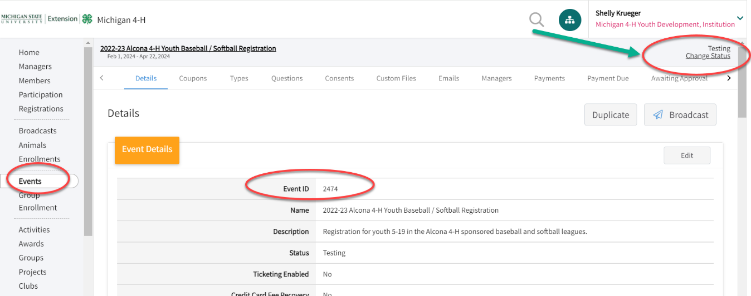

Begin to EDIT your event.
Make all DATE changes.
Including:
- Event name
- Description
- Start & End Dates
- Splash Images
- Registration Types
  - Each type will need the registration dates RE-Set for the current program year
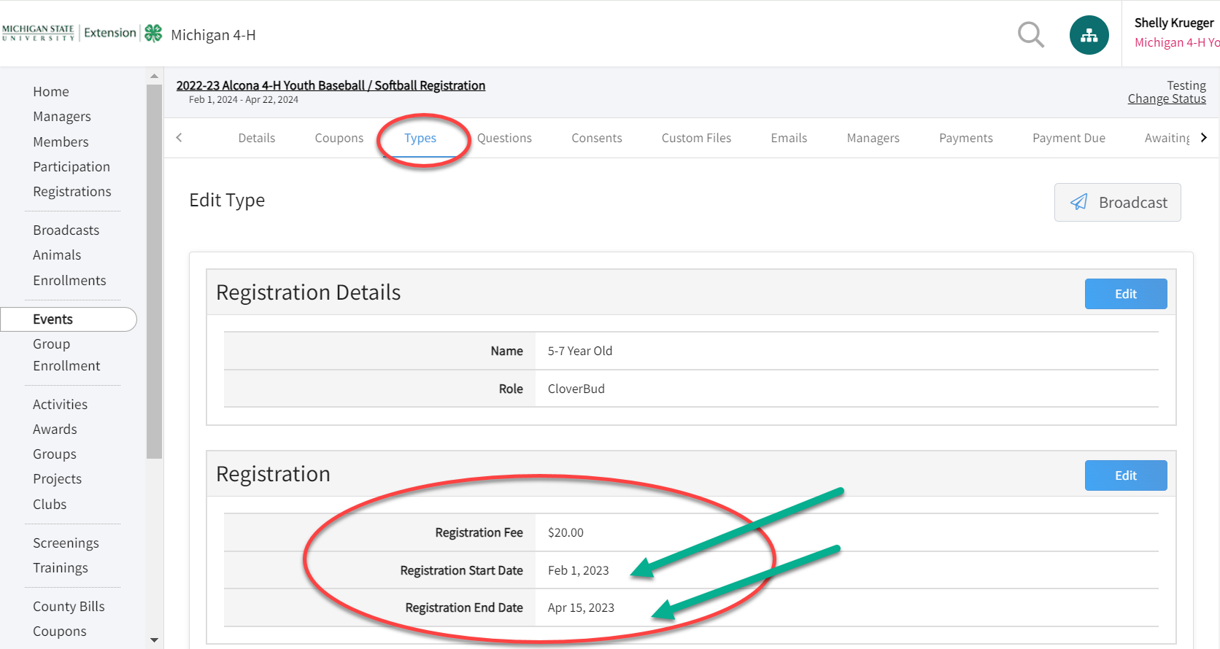
- Review ALL questions
  - Make sure to EDIT any references to DATES.

- Modify the EMAIL setup to update them with current DATE references.

Review ALL areas/settings for your event. Make any changes to questions/consents/custom files/emails/managers/ etc.
Remember – your event copied over ALL text and dates from the prior year’s event.
It is up to you to make the changes and update the event with the current program year event information.

